



|  |
| --- |
| **PR Activity- July 2021** |

**PR Activity July 2021**

|  |
| --- |
| **Highlights of the Month:**  1. We have received total 66 coverages- 36 print, 30 online.  2. We have received 17 SIPM coverage,4 Suguna Foods and 45 Suguna Daily Fressh coverage in total.  3. A press release on the topic ‘Suguna Daily Fressh provides safe and hygienic chicken’ was disseminated and carried across publications pan India.  4.    ‘Suguna Foods introduces Value Added Eggs across age groups’ press release garnered good visibility pan india  5.  The press release on the topic ‘Suguna Institute of Poultry Management to start admissions for undergraduate and diploma programmes’ was carried across publications pan India.  6. Our influencer and nutritionist Ms. Urvi Arjan Gajra, wrote on the topic ‘Vitamin D deficiency and the need to consume chicken and eggs’ and this was published in Dinakaran Vasantham, a leading news daily in Tamil Nadu. |

**Name of the Media:** Chandrika

**Date:** 04.07.2021

**Region:** Kerala



**Name of the Media:** Future Kerala

**Date**: 04.07.2021

**Region**: Kerala

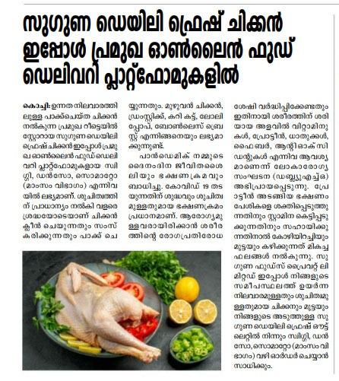

**Name of the Media:** Kerala Vartha

**Date:** 04.07.2021

**Region**: Kerala

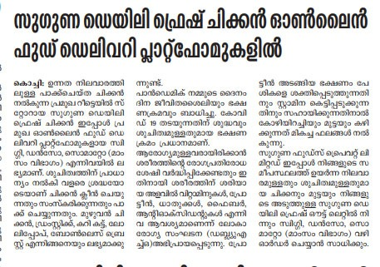

**Name of the Media**: Kerala Prananam

**Date:** 04.07.2021

**Region:** Kerala

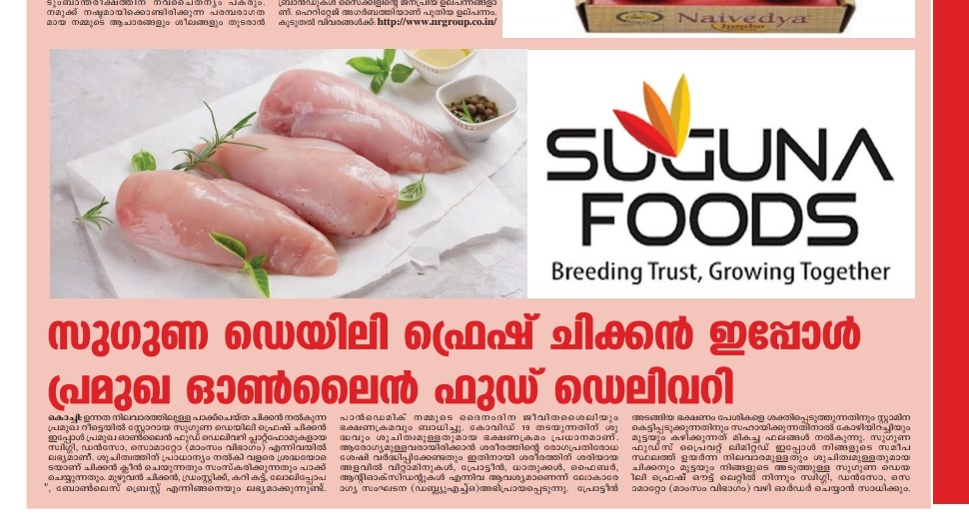

**Name of the Media**: Veekshanam

**Date**: 04.07.2021

**Region**: Kerala

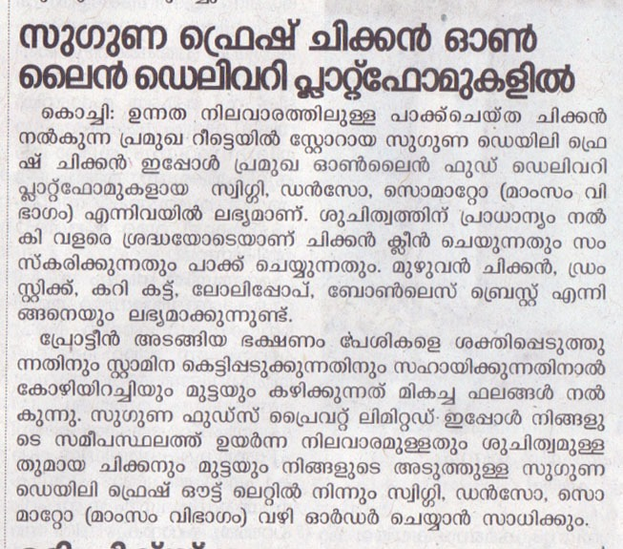

**Name of the Media**: Vanakam Thamilagham

**Date**: 04.07.2021

**Region:** Tamil Nadu

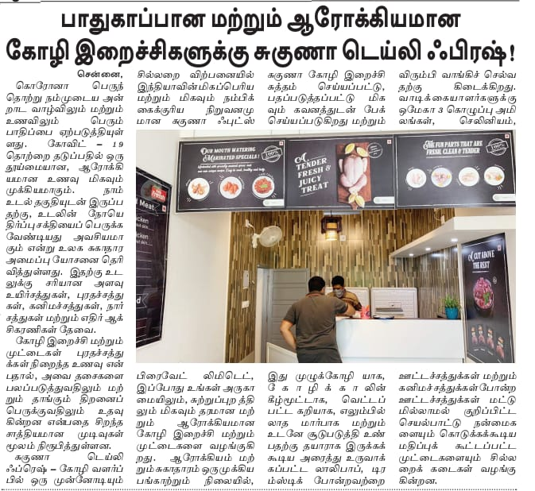

**Name of the Media:** Deepika

**Date:** 05.07.2021

**Region:** Kerala



**Name of the Media**: Malai Thamilagham

**Date:** 05.07.2021

**Region:** Tamil Nadu

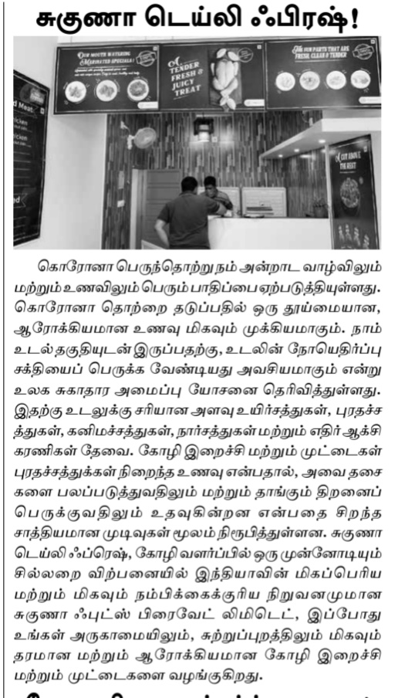

**Name of the Media:** Thozhi Nesan

**Date**: 05.07.2021

**Region:** Tamil Nadu

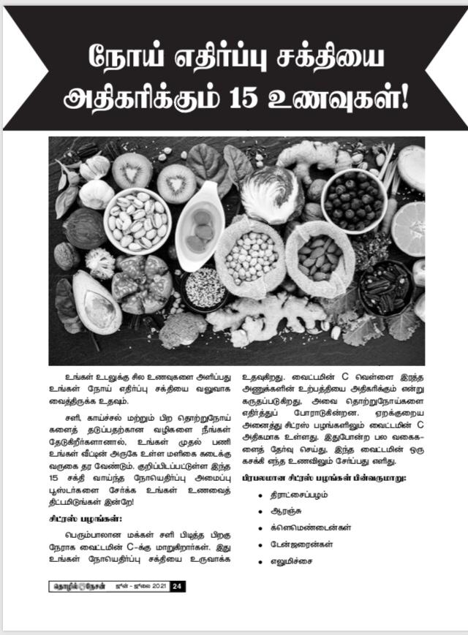

**Name of the Media**: Dhinathodar

**Date**: 07.07.2021

**Region:** Tamil Nadu

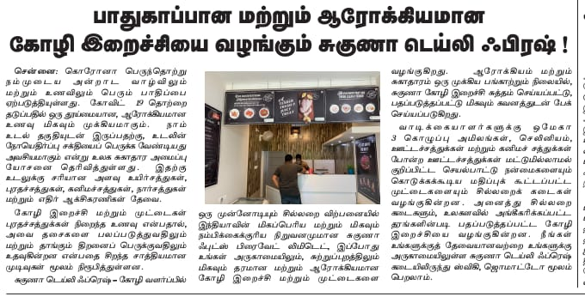

**Name of the Media**: Metro Vartha

**Date:** 07.07.2021

**Region**: Kerala



**Name of the Media**: Subashistha

**Date:** 08.07.2021

**Region:** Karnataka

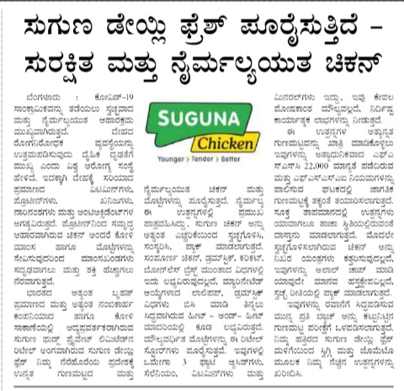

**Name of the Media**: Malayalamanorama

**Date:** 09.07.2021

**Region**: Kerala

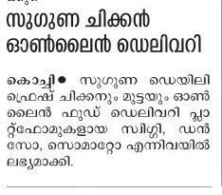

**Name of the Media:** News Today

**Date:** 09.07.2021

**Region:** Tamil Nadu



**Name of the Media:** Amrit India

**Date:** 20.07.2021

**Region**: News Delhi

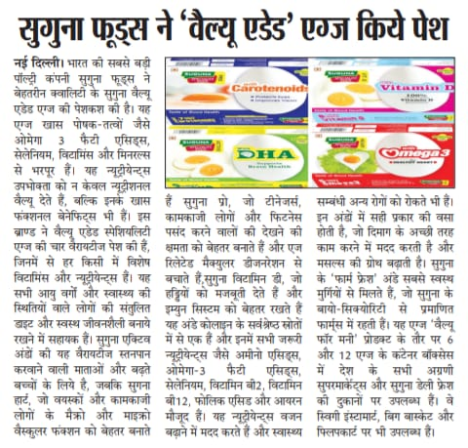

**Name of the Media:** Deshbandhu

**Date:** 20.07.2021

**Region:** News Delhi

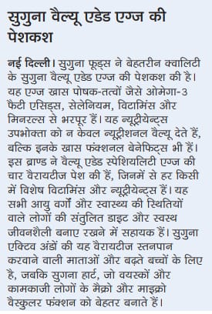

**Name of the Media**: Deshratna

**Date:** 20.07.201

**Region:** New Delhi

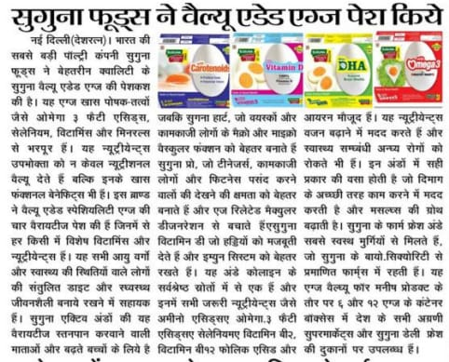

**Name of the Media:** Gurgaon Today

**Date:** 20.07.2021

**Region**: New Delhi

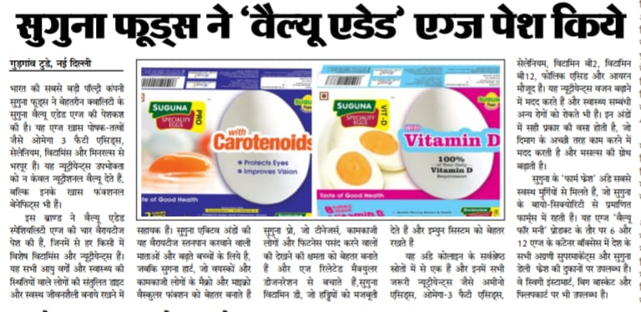

**Name of the Media**: Dhinathodar

**Date**: 21.07.2021

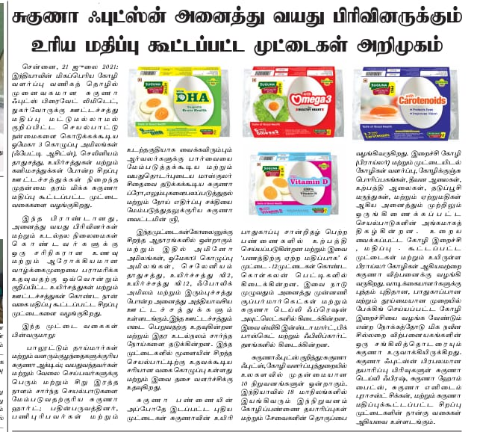**Region**: Tamil Nadu

**Name of the Media:** Punjab Kesari

**Date:** 21.07.2021

**Region:** New Delhi

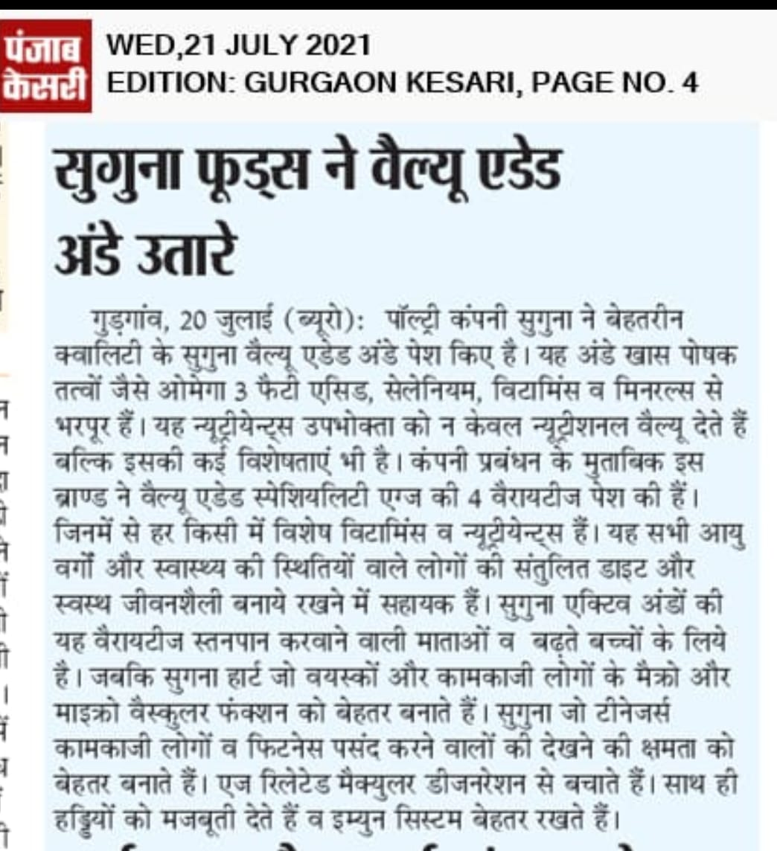

**Name of the Media**: Shambad Vani Samachar

**Date**: 21. 07.2021

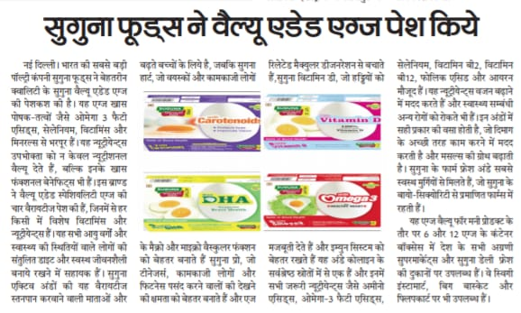**Region:** New Delhi

**Name of the Media:** Uttar Prahari

**Date:** 21.07.2021

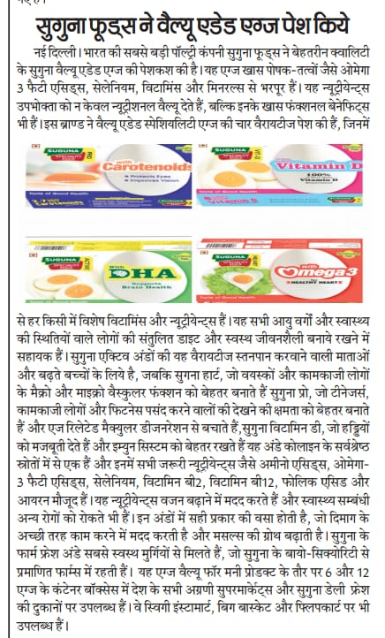**Region:** New Delhi

**Name of the Media:** New Indian Express

**Date:** 22.07.2021

**Region:** New Delhi

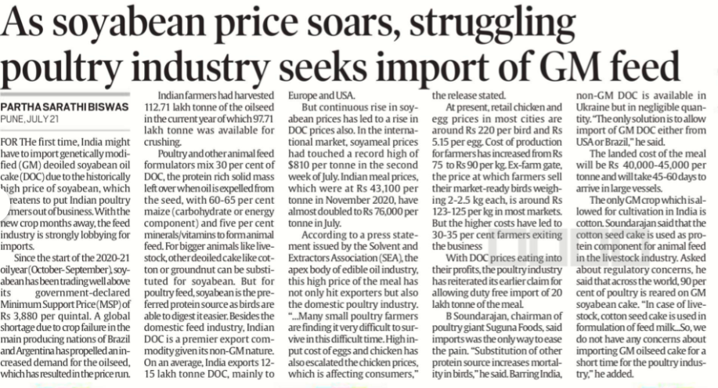

**Name of the Media:** Amrit India

**Date:** 23.07.2021

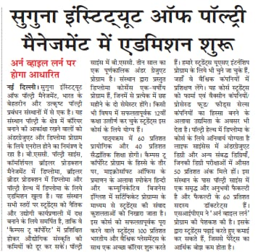**Region:** New Delhi

**Name of the Media:** Deshbandhu

**Date:** 23.07.2021

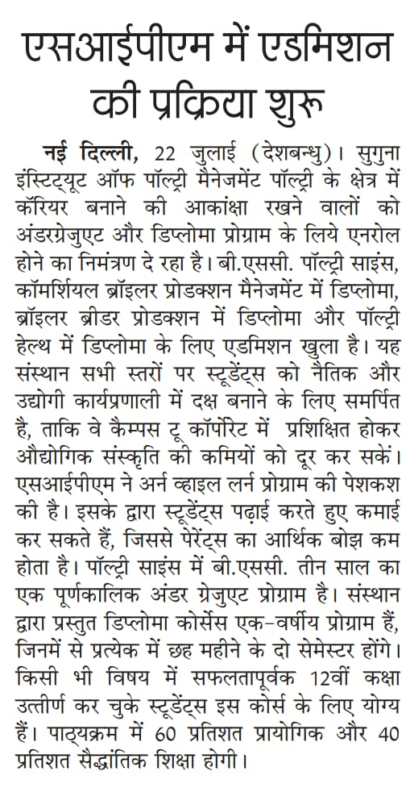**Region:** New Delhi

**Name of the Media:** Malai Thalilagham

**Date:** 23.07.2021

**Region:** Tamil Nadu

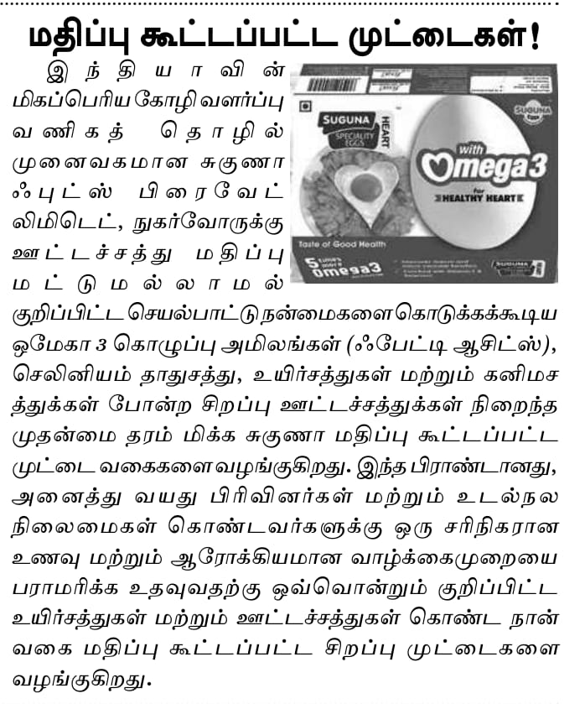

**Name of the Media:** Shivner

**Date:** 23.07.2021

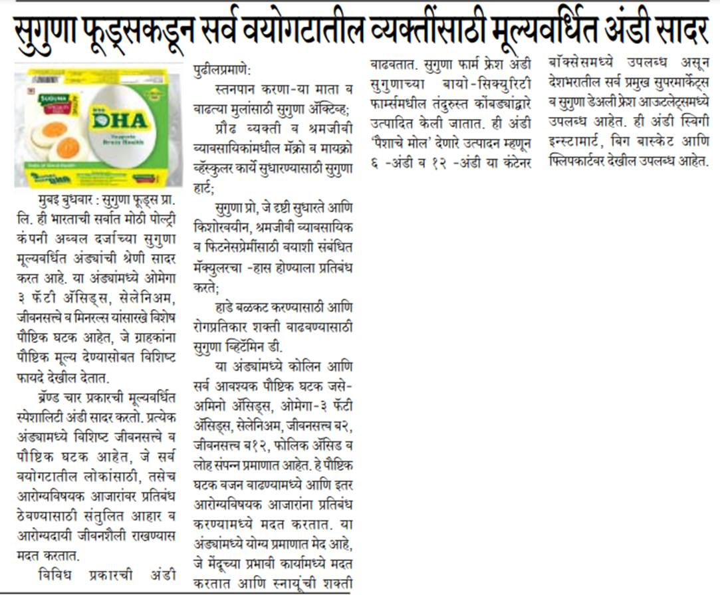**Region:** Maharashtra

**Name of the Media:** The Global Times

**Date**: 23.07.2021

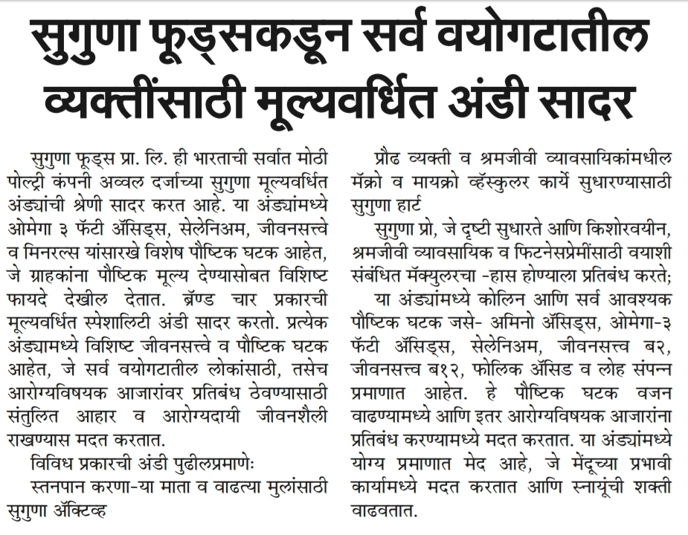**Region:** Maharashtra a

**Name of the Media**: Vanakam Thamilagham

**Date:** 23.07.2021

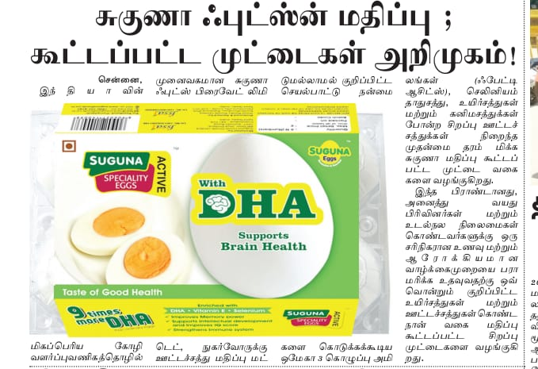**Region:** Tamil Nadu

**Name of the Media:** Navbharat

**Date:** 25.07.2021

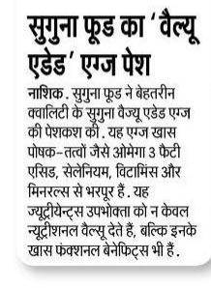**Region:** Maharashtra

**Name of the Media:** Veer Arjun

**Date:** 25.07.2021

**Region:** New Delhi

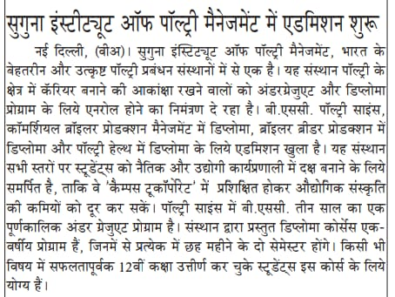

**Name of the Media**: Sakal

**Date:** 26.07.2021

**Region:** Maharashtra

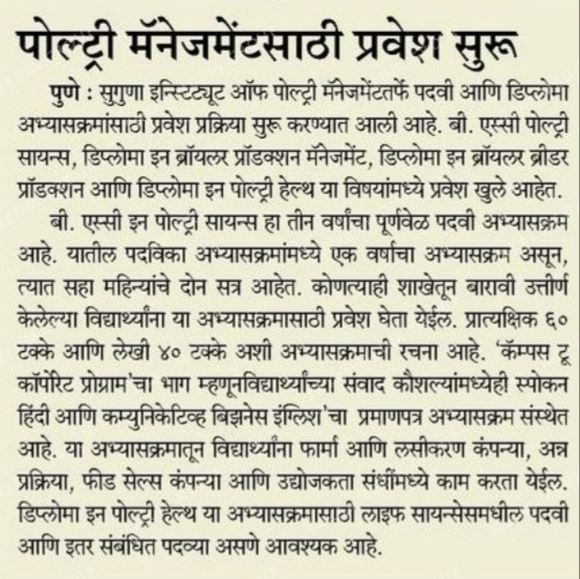

**Name of the Media:** Dinakaran Vasantham

**Date**: 26.07.2021

**Region**: Tamil Nadu

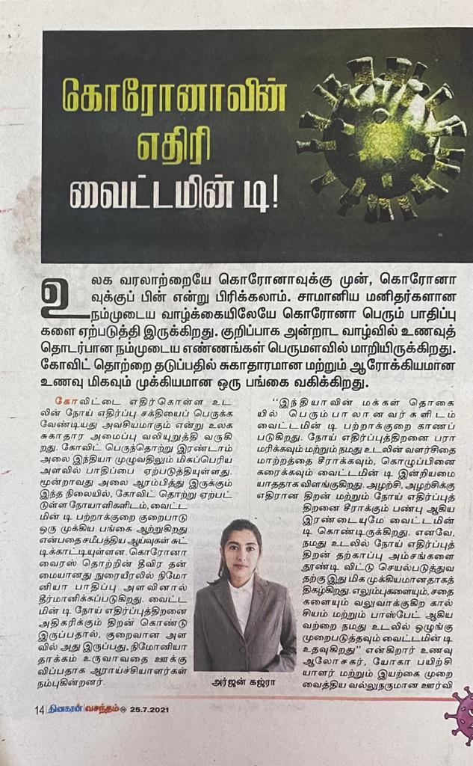

**Name of the Media:** The Global Times

**Date:** 26.07.2021

**Region:** Maharashtra

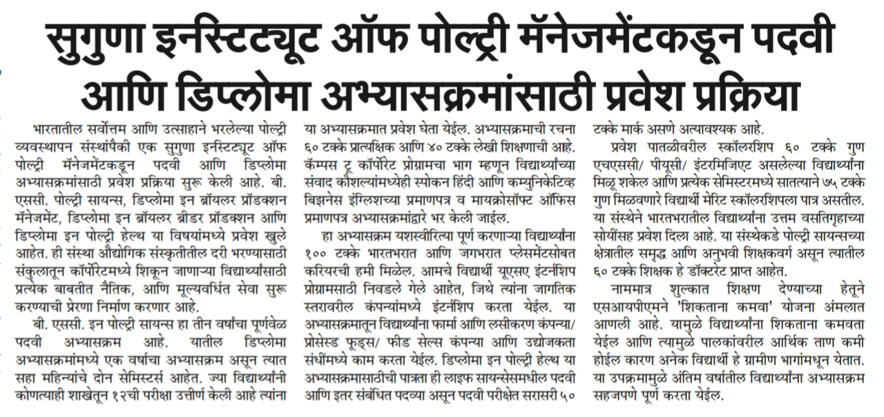

**Name of the Media**: Navbharath

**Date:** 26.07.2021

**Region**: Maharashtra

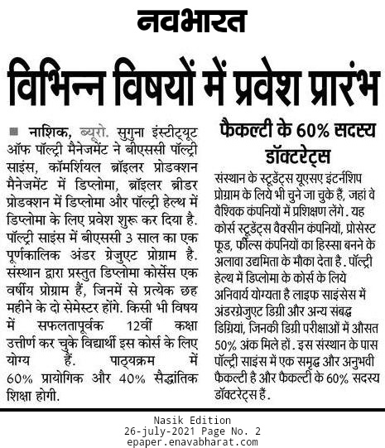

**Name of the Media**: Shivner

**Date:** 28.07.2021

**Region:** Maharashtra

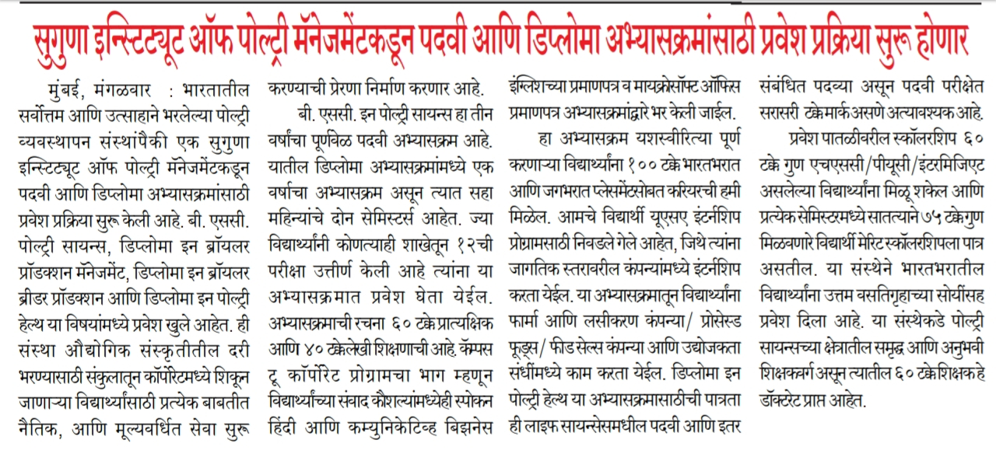

**Online Coverages:**

|  |  |  |  |  |
| --- | --- | --- | --- | --- |
| 1 | 03.07.2021 | Chennai patrika | Suguna Daily Fressh provides safe and hygienic chicken | <http://news.chennaipatrika.com/post/suguna-daily-fressh-provides-safe-hygienic-chicken> |
| 2 | 03.07.2021 | PNI news | Suguna Daily Fressh provides safe and hygienic chicken | <https://www.pninews.com/suguna-daily-fressh-provides-safe-hygienic-chicken/> |
| 3 | 04.07.2021 | Malayalam samayam | Suguna Daily Fressh provides safe and hygienic chicken | <https://malayalam.samayam.com/business/business-news/suguna-chicken-now-get-in-online-food-delivery-platforms-like-swiggy-zomato/articleshow/84086472.cms> |
| 4 | 04.07.2021 | Sathya online | Suguna Daily Fressh provides safe and hygienic chicken | <https://www.sathyamonline.com/suguna-daily-fresh-chicken-538199-2/> |
| 5 | 04.07.2021 | Business onlive | Suguna Daily Fressh provides safe and hygienic chicken | <https://www.businessonlive.com/shopping/69709> |
| 6 | 04.07.2021 | Times Kerala | Suguna Daily Fressh provides safe and hygienic chicken | <https://timeskerala.com/archives/538264> |
| 7 | 05.07.2021 | Business news this week | Suguna Daily Fressh provides safe and hygienic chicken | <http://businessnewsthisweek.com/business/suguna-daily-fressh-provides-safe-hygienic-chicken/> |
| 8 | 05.07.2021 | Media bulletins | Suguna Daily Fressh provides safe and hygienic chicken | <http://mediabulletins.com/business/suguna-daily-fressh-provides-safe-hygienic-chicken/> |
| 9 | 05.07.2021 | Digital media 9 | Suguna Daily Fressh provides safe and hygienic chicken | <https://digitalmedia9.com/business/suguna-daily-fressh-provides-safe-hygienic-chicken/> |
| 10 | 05.07.2021 | Online media cafe | Suguna Daily Fressh provides safe and hygienic chicken | <https://onlinemediacafe.com/business/suguna-daily-fressh-provides-safe-hygienic-chicken/> |
| 11 | 05.07.2021 | Content media solution | Suguna Daily Fressh provides safe and hygienic chicken | <https://contentmediasolution.com/foods/suguna-daily-fressh-provides-safe-hygienic-chicken/> |
| 12 | 05.07.2021 | Covai Mail | Suguna Daily Fressh provides safe and hygienic chicken | <http://www.covaimail.com/?p=49425> |
| 13 | 05.07.2021 | TV 9 Marathi | Included these 5 foods in your diest regulary to increase height | <https://www.tv9marathi.com/lifestyle/khana/include-these-5-foods-in-your-diet-regularly-to-increase-height-488697.html> |
| 14 | 07.07.2021 | The Economic Times | Covid induced weekend lockdowns hit poultry industry | <https://m.economictimes.com/news/economy/agriculture/covid-induced-weekend-lockdowns-hit-poultry-industry/articleshow/82431164.cms> |
| 15 | 19.07.2021 | Covai Mail | Suguna Foods Introduces value added eggs across age groups | <http://www.covaimail.com/?p=50208> |
| 16 | 19.07.2021 | RD times | Suguna Foods Introduces value added eggs across age groups | <https://rdtimes.in/suguna-foods-introduces-value-added-eggs-across-age-groups/> |
| 17 | 19.07.2021 | Biz, RD times | Suguna Foods Introduces value added eggs across age groups | <https://biz.rdtimes.in/suguna-foods-introduces-value-added-eggs-across-age-groups/> |
| 18 | 19.07.2021 | The Indian Bulletin | Suguna Foods Introduces value added eggs across age groups | <https://biz.theindianbulletin.com/suguna-foods-introduces-value-added-eggs-across-age-groups/> |
| 19 | 19.07.2021 | Lifestyle RD times | Suguna Foods Introduces value added eggs across age groups | <https://lifestyle.rdtimes.in/suguna-foods-introduces-value-added-eggs-across-age-groups/> |
| 20 | 19.07.2021 | Indian Press release | Suguna Foods Introduces value added eggs across age groups | <http://www.india-press-release.com/press/press_featured/regular/2982/suguna-foods-introduces-value-added-eggs-across-age-groups> |
| 21 | 20.07.2021 | Indian News | Suguna Foods Introduces value added eggs across age groups | <https://indiannewz.wordpress.com/2021/07/19/suguna-foods-introduces-value-added-eggsacross-age-groups/> |
| 22 | 20.07.2021 | Business News this Week | Suguna Foods Introduces value added eggs across age groups | <http://businessnewsthisweek.com/health/suguna-foods-introduces-value-added-eggs-across-age-groups/> |
| 23 | 20.07.2021 | Media Bulletins | Suguna Foods Introduces value added eggs across age groups | <http://mediabulletins.com/health/suguna-foods-introduces-value-added-eggs-across-age-groups/> |
| 24 | 20.07.2021 | RD times | Suguna Institute of Poultry Management to start admissions for undergraduate and diploma programmes | <https://rdtimes.in/suguna-institute-of-poultry-management-to-start-admissions-for-undergraduate-and-diploma-programmes/> |
| 25 | 20.07.2021 | Edu. RD times | Suguna Institute of Poultry Management to start admissions for undergraduate and diploma programmes | <https://edu.rdtimes.in/suguna-institute-of-poultry-management-to-start-admissions-for-undergraduate-and-diploma-programmes/> |
| 26 | 20.07.2021 | Indian Sentinel | Suguna Institute of Poultry Management to start admissions for undergraduate and diploma programmes | <https://indiansentinel.in/suguna-institute-of-poultry-management-to-start-admissions-for-undergraduate-and-diploma-programmes/> |
| 27 | 21.07.2021 | APN News | Suguna Institute of Poultry Management to start admissions for undergraduate and diploma programmes | <https://www.apnnews.com/suguna-institute-of-poultry-management-to-start-admissions-for-undergraduate-and-diploma-programs/> |
| 28 | 21.07.2021 | Business news this week | Suguna Institute of Poultry Management to start admissions for undergraduate and diploma programmes | <http://businessnewsthisweek.com/education/suguna-institute-of-poultry-management-to-start-admissions-for-undergraduate-and-diploma-programmes/> |
| 29 | 21.07.2021 | Media Bulletins | Suguna Institute of Poultry Management to start admissions for undergraduate and diploma programmes | <http://mediabulletins.com/education/suguna-institute-of-poultry-management-to-start-admissions-for-undergraduate-and-diploma-programmes/> |
| 30 | 22.07.2021 | Indian Express | Pune Indian Poultry Industry seeks GM feed import | <https://indianexpress.com/article/cities/pune/pune-indian-poultry-industry-seeks-gm-feed-import-7415825/> |